# WSPD:Weakly Supervised Network for Polyp Detection

**Xiuquan Du, Jiajia Chen, Xuejun Zhang, Hancheng Wu** and **Lou Sun**

School of Computer Science and Technology, Anhui University, Hefei, China

dxqllp@ahu. edu. cn

# 1. Introduction

Colorectal cancer (CRC) is the third most common malignancy and the second most common cause of cancer death . Its incidence continues to rise in lower-middle income countries and remains high in most developed countries, which will further threats to health [19] . Polyps are anomalous tissue and the early feature of cancer . Studies have shown that colonoscopy, which is the gold standard for prevention and diagnosis, can reduce CRC by 30% [1] . However, the recall of colonoscopy depends extremely on the experience of clinicians . Clinical studies proven that the omission rate of 8. 65% by skilled physicians and 57. 14% by unskilled physicians [23] . Missed polyps can lead to survival rate as low as 10% [21] . Therefore, a computer-aided technique (CAD) is essential for the accurate and comprehensive detection of polyps.

Traditional polyp detection methods have relied on classifiers to distinguish polyps from their surroundings, using a combination of features such as colour wavelet analysis, local binary pattern (LBP), texture, Haar, directional gradient histogram (HoG) and other features based on colour, texture and shape. These methods are crucial for the identification of abnormal growths in the mucosa. However, polyps often resemble surrounding features, manual feature representation is limited and size range is exceptionally large, which results in higher miss rates in such models [15] .

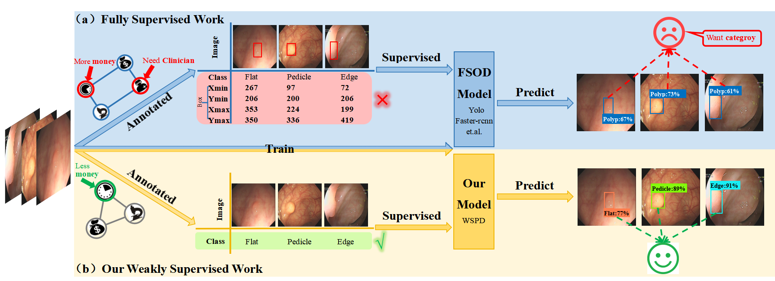

Figure 1. (a) Fully supervised polyp detection (FSPD) uses the instance-level annotations as supervision. (b) Our weakly supervised polyp detection (WSPD)uses the image-level annotations as supervision.

Deep learning has transformed the approach to manual feature learning. Recently, promising results have been achieved with fully supervised polyp detection (FSPD) through Faster-Rcnn [16] and YOLO [17] . As shown in Fig1(a), the strategy is to label the class and boxes (xmin, ymin, xmax, ymax) of polyps, which will be used as label to supervise the training of the algorithms. Eventually, predicting the boxes and confidence level of polyps in the image.

While fully supervised methods have shown favourable outcomes, this approach lacks clinical appropriateness: i)Polyps won't be marked during the clinical diagnostic process [14], which increases the time and workload for clinicians to annotate the data. ii) FSPD relies on a large amount of datasets with accurate instance-level annotation, which needs boxes and has the high requirements for annotators. iii)The evaluation criteria of the existing network are meaningless. The research shows that the missed diagnosis rate of flat polyps is up to 23. 52%, while the missed diagnosis rate of raised polyps is 8. 95% [23] . Therefore, polyp shape should be given priority in the training or evaluation of polyp detection networks. Actually, current work focuses on either the presence of polyps or the effectiveness of bi-category polyp detection, as shown in Fig2(a). Considering the problems, in this paper, we design the weakly supervised polyp detection method with image-level labeling, as shown in Figure 1(b). Our method annotates the image with image-level polyp morphology, feeds the image into the proposed weakly supervised polyp detection network (WSPD) for training, and outputs the detection with boxes and category confidence classified by morphology in the image.

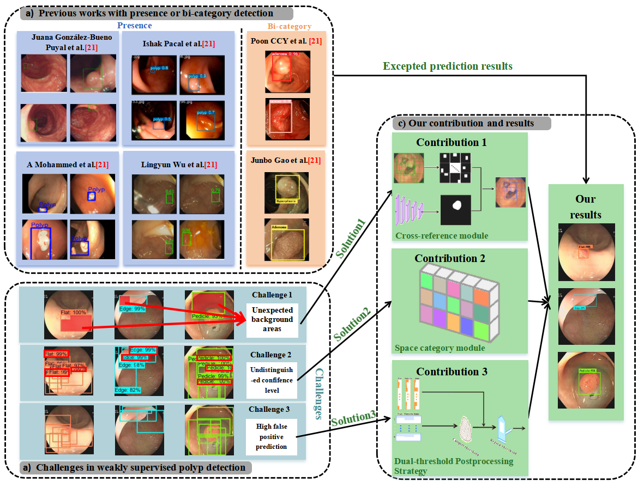

Figure 2. Detection results from established methods and challenges within our framework. (a) is previous works with presence or bi-category detection. (b) is challenges in weakly supervised polyp detection. (c) is our methods with the excepted prediction.

Earlier research proposed a solution for weakly supervised object detection with image-level supervision, as demonstrated by Bilen et al [22], whose approach is to use Selective Search Windows(SSW) to grenete proposals and pre-trained CNN to describe image regions, then combines with MIL to build an end-to-end weakly supervised detection network. However, in practice, we observe that the network's detection structure tends to select candidate boxes that contain a significant number of background regions, while only containing polyps in a localised area, as shown in Figure 2(b) challenge1. We also observe that the classification structure of the network does not learn the most discriminating parts of the different categories at the beginning of training, but gradually overfits as the number of training epochs increases. Eventually the network's post-processing is unable to accurately filter them, as shown in Figure 2(b) challenge2. Furthermore, observing the candidate boxes of the same image also shows that there is a large amount of spatial redundancy in the different candidate boxes generated by SSW as shown in Figure 2(b) challenge3, which not only disrupts the network's training but also results in superfluous computation.

Given the above observations, we propose a Cross-domain reference module(CRM) that pre-trains a polyp segmentation network using a publicly available colon polyp dataset, then decentralises it to a private dataset to generate pseudo-labels, and finally uses the obtained pseudo-labels as a reference to filter proposals generated by SSW in the data pre-processing. In this way, the network has the ability to eliminate potential suggestions before starting training, minimizing the impact of imprecise regions on the network's detection structure and reducing computation during detection.

To further improve the discriminative abilities of the proposed network, we design the Spatial Category Module (SCM) in the backbone network. Our belief is that global pooling will drastically reduce the network parameters. Consequently, the network will put more learning pressure on the feature extraction stage. Thus, it will be required to learn not only high-level classification features, but also low-level compositions such as position, shape and size. Therefore, we sign a category-driven spatial classification module to take full account of the global characteristics of the target, thereby increasing the ability of the network to perform accurate discrimination and detection.

To reduce the number of false positives in the network, we propose a Dual-threshold post-processing strategy(DPS), which is motivated by the notion that the confidence of boxes packed densely is the highest. In the first step, the candidacies are filtered by the category threshold to drop low category scores results, and then the region threshold is implemented to waiver low region scores boxes. This post-processing mechanism identifies and eliminates redundant boxes during the secondary filtering stage, which can reduce the rate of false positive detection.

Indeed, it is important to note that the joint learning of classification and box regression has been proven beneficial for fully supervised polyp detection. But it remains a challenging task for weakly supervised polyp detection and requires innovative ideas and insight. Our contributions can be briefly summarized as follows:

* We designed a Cross-domain reference module to reduce network localization interference and improve network localization accuracy.
* We designed a Spatial category module to enhance the ability to learn features, and the localization and categorization ability made significant progress.
* We designed a Dual-threshold post-processing strategy to refine the filtering conditions, and the category average accuracy was significantly improved.
* We are the first work on weakly supervised detection guided by colon morphology categories, with significant results on datasets.

# **2. Related Work**

## 2.1. Polyp Segmentation Network

Ronnebergeretal et al. proposed the medical segmentation network Unet [27], which uses an end-to-end architecture with a coding-decoding structure. Because of its accuracy, generality to the task, and easiness of implementation, subsequent work followed the standard example. For example, Unet++ [28] uses a branch-cut strategy to speed up inference and address unknown depths. ResUnet++ [29] fuses residual strategies to solve the gradient vanishing, includes SE block (squeeze and excitation block) to enhance the sensitivity of relevant features and suppress interference, and ASPP module to integrate different sizes of contextual information.

However, these methods do not handle polyp boundaries well. Subsequently, PraNet [26], PsiNet [30], MSNet [32] and SFANet [33], LODNet [31] force the model to learn the polyp boundary differences, which greatly enhances the model's ability to discriminate the polyp boundaries, and achieves satisfactory results. In addition, ACSNet [34], HRENet [35], and CCBANet [36] obtained high confidence predictions by focusing on contextual information, aggregating multi-scale context, and reducing local feature ambiguities. ICGNet [37] used an inverse contour guiding module to aggregate the underlying edge information, constrain the inverse region, and used an adaptive context module to extract the current layer's local global information and complementary information of the previous layer, expanding the dense features to solve the problems of size difference, irregular shape, and boundary ambiguity.

## 2.2. Weak supervision object detection

The problem to be solved for weakly supervised target detection coincides with the research goal of multiple example learning (MIL) [38] in weakly supervised learning, and thus weakly supervised target detection is usually treated as a multiple example learning problem. Bilen [22] firstly proposed a framework for weakly supervised target detection based on multiple example learning. The important challenge of mapping instance-level candidate box scores to image-level category labelling is addressed. The complete framework contains three main parts: 1) Candidate box generator. Selective search windows [24] or Edge boxes [39] algorithms are used to generate a large number of target candidate boxes on the input image; 2) Feature extraction. CNN is used to extract features from the input image, and then spatial pyramid pooling [40] or region of interest pooling [41] is used to generate a fixed-size candidate box feature matrix; 3) Detector. The candidate frame features are mapped to the image category labels, and the multi-example learning loss function is computed to complete the localisation and classification of target objects in the image.

# **3. Method**

In this section, we present the structure of the weakly supervised polyp detection network and the dual-threshold post-processing strategy. The structure of the network consists of three main components: a Cross-domain reference module(CRM), a spatial category module (SCM), and a multiple instance branch.

The overall architecture is shown in Figure 3. Given an image, the features are extracted by the pre-trained ConvNet on ImageNet [42] and the trained proposals are generated by the cross domain control module. Then, send them to the ROI pooling layer with features for region feature mapping, The results are fed to the spatial category module and the multiple instance branch to obtain location or category score, respectively. After that, the scores are dotted product, clamped column sums to form prediction results. The regression training of the network is guided by the categorical labels y = [y1, y2, ···, yC] ∈{0, 1}C, where yc = 1 or 0 denotes the presence or absence of an object class c. The rest of this section discusses these three modules in detail, as well as the dual-thresholding post-processing strategy.

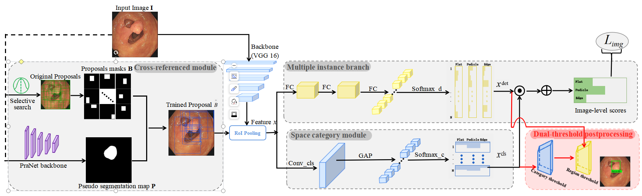

Figure 3. Overview of the proposed WSPD. The WSPD consists of end-to-end architecture, including three parts for train with cross-reference module (CRM), multiple instance branch, space category module (SCM) and an extra dual-threshold post-processing for test. The solid ellipses denote the image-level loss functions . The black and red arrows are denoted as train data streams and post-processing operations, respectively.

## 3.1. Cross-domain reference module

We generated polyp candidate proposals using SSW algorithm to locate polyps. However, the generated proposals have a large number of errors and spatially redundant proposals, which bring noise to the detection. To solve the above problems, we propose a cross-domain reference module(CRM) to generate proposals with less noise interference.

Specifically, we pre-trained a segmentation network heterocentric to our data on the publicly available colon polyp dataset, after which we fed our data into the network to produce segmentation results (P). At the same time, an SSW algorithm is used to generate initial candidate frames for our data and transform them into binary masks (B). Intuitively, if if B differs significantly from P, then B may be a hard or mislabelled sample, as the pre-trained segmentation model must have learnt some generic features of the polyp. In this case, this bounding box will be filtered out from model training. As a result, the problem shown in Figure 1(d) will be alleviated.

In practice, we divide the dataset CVC-ClinicDB/CVC-612 [25] according to the ratio of 8:2 and select PraNet [26] as the segmentation network (S) for training. 80% of the data is used to train the network, 20% of the data is used to test the performance of the network, and the weight parameters when the network performs best are saved. Given our private dataset image I, we use it as an input segmentation network S, load the saved weighting parameters and get the prediction result P with the following formulation:



where I denotes the input image and w is the weight of the pre-trained segmentation network S. P is a binary segmentation map for two class with a size of h×w.

At the same time, the SSW algorithm is applied to the image and the binary mask is converted to obtain the coarse candidate box B. The Jaccard Coefficient jc=  is chosen to measure the difference between B and P, and only  the candidate boxes are selected, and the final output is the refined candidate box ={b1, b2, . . ., bN}(where N is the number of proposals), the formula is as follows:





wheredenote is filtering threshold and SSW is the Selective search windows, Details are referred to [24] . For each image, is a shortlist of candidate object proposals . Each element B(i, :) indicates the coordinate value of the proposals and the form is (xmin, ymin)、(xmax, ymax).

After optimization according to Eq. (3), potential noise interference can be minimized, and fine candidate boxes are fed into the network for subsequent training.

## **3.2. Spatial Category Module**

Generally, the pattern of training multiclassification network is to extract features from convolutional network, flatten the features to one-dimensional vectors by fully connected layer, and give classification to different categories by softmax. However, the ways of directly flattening to make fully connected retains a lot of spatial information, since larger region with more variation are more likely to have high category consistency across the whole training set.

To ensure the accuracy of the classification, we design the spatial category module(SCM). Formally, the spatial category module contains a convolutional layer, a global average pooling layer and a Flatten layeras follows:



where  is a flatten operation and  is a Global Average Pooling (GAP) layer to get the classification score map. w and b are the parameters of the spatial category module, which is a 3 × 3 convolutional layer. Then, it is delivered to the softmax operator. The classification scores can be calculated by:



The classification scores is a matrice with the same shape as the detection scores, which is described in detail in the next section. In this case, we expect it to learn more foreground/background information to help categorize objects.

## **3.3. Mutiple Instance** Branch

We only have image-level labels to indicate whether an object category is present or not. In order to train a standard object detector with regression, it is necessary to tap into instance-level supervision. The multi-instance detection module performs detection by scoring regions relative to each other. Given a region feature mapping graphextracted from a ConvNet, the multiple instance detection module takes it as input and outputs a detection scores matrice 。Specifically, the feature mapping map is fed into three tandem fully connected layers FC1~3 to obtain the candidate proposals stretching vector. This is then passed to the softmax operator, this time defined as follows:





Here,  has  channels, which differents from the input feature map channels, and the former is the result of the fully connected layer processing. Each elementindicates the probability of the ith proposal bi belonging to the jth category.

In the case, in fact, the softmax operator compares, for each region independently, class scores。In this method, In this method, the module can evaluate which region holds a better information image fragment.

After that, the scores of all proposals are generated by element-wise product⊙. During the training stage, the loss function can be formulated as follows:



## **3.4. Dual-threshold Postprocessing Strategy**

To achieve accurate prediction that efficiently captures object parts while optimally covering background, we propose a Dual-threshold post-processing strategy(DPS). In this method, the results of the detection are filtered by two thresholds, which are specifically designed for the given task.

**Category filtering strategy** Although categories may not be able to distinguish candidate frames with high spatial coverage in terms of categories, they are effective in distinguishing the target from the background. To filter out untrustworthy candidates, we set a category threshold, and only candidates with category confidence greater than the threshold are retained. After that, non-maxima suppression (with the threshold) is applied to the proposals. Finally, proposals with scores higher thanand overlap lighter than are held for the further filtering process.

**Region filtering strategy** As mentioned, filtering only on categories leads to a large number of false positive (FP) predictions. This is due to the fact that classification is unable to select the most valuable regions, and it prefers candidate frames that contain a lot of background as predictions because they have more categorical information. In contrast to this region confidence is more concerned with whether the candidate frames are tightly surrounding the object. So naturally, we further set the region thresholds which are dynamically changing unlike the fixed category thresholds. Consider the worst situation, where the candidate frames input to the network have a high spatial overlap and tightly frame different parts of the object. In this case, the region scores of the candidate frames are averaged across the candidate frames. Therefore, we set the region threshold to the worst-case mean normalisation with the following formula:



where N denotes the number of proposals in an image, and the result is between 0 and 1.

# 4. Experiments

In this section, we introduce the evaluation datasets, present the implementation details of our proposed approach. Then we perform thorough experiments to analyse our WSPD and its components for weakly supervised polyp detection.

## 4.1. Experimental Setup

**Datasets.** Experiments are conducted on two polyp datasets: publicly available CVC-ClinicDB [25] and our private dataset.There was no patient overlap in the public

training and test sets. CVC-ClinicDB is just for CRM, which contains 612 images from 29 different colonoscopy sequences with polyp regions, manually annotated by experienced doctors. Private dataset is used for WSPD, including patients from The Second Hospital of Anhui Medical University ( Furong Road, Hefei Economic Development Zone, Hefei City ) .

**Implementation.** For the backbone we use VGG16 [43] to extra feature, which pretrained on ImageNet [42] and has some conv layers with max-pooling layer. We replace the last max-pooling layer of the model by ROI Pooling layer. To reduce errors and redundancies of candidate regions, cross-domain reference module is added and the PraNet[26]is selected for the segmentation network,which details are formulated in Section 3.1. To categorise polyps, we develop a spatial category module consisting three operations of convolution, global average pooling and softmax in Section 3.2. To locate polyps, we apply three different fc layers and the last fc layer, softmax operation and image-level loss are described in Section 3.3.

We follow a two-step training strategy: 1) the segmentation network is trained with fixed learning rate 10-4 for 20 epochs. 2) the entire architecture is trained following the end-to-end manner. The WSPD runs for 15 epochs with 10-5 following 10 epochs with learning rate 10−6. To achieve the filtration of initial candidate proposals and detection post-processing, the value of the threshold are simply set, i.e. , , , respectively. Reviews and additional details are presented in Table 1.

|  |  |  |  |  |  |
| --- | --- | --- | --- | --- | --- |
| Network | Datasets | LR | Epochs | Optimizer | Device(Trained) |
| PraNet | CVC-ClinDB (8:2) | 1e-4 | 20 | Adam |  |
| WSPD | Private (8:2) | 1e-5 | 15 |

Table 1: Implementation details for our proposed method.

## 4.2. Ablation experiments

For the sake of evaluating the effectiveness of the three key components in our proposed method, we conducted excessive ablation studies on our private dataset with all the combinations of multi-pretext tasks of CRM, SCM, and DPS with consistency loss.There are four ablation types as below:1) Original task:Baseline 2) Single pretext task: CRM, SCM, DPS 3) Dual pretext task: CRM+SCM, CRM+DPS, SCM+DPS 4) Triple pretext task: CRM+SCM+DPS. The results are shown in Table 2. The foundational detection method without any pretext is the same as the WSDDN[22], and we continually add modules as mentioned strategies above. When the implementation of aforementioned modules by degree, boosting mAP by 6.64%, 8.4%, 9.83%, 13.26%, 11.01%, 13.93% and 24.52%. These results proves the effectiveness and necessity of the dual-threshold postprocessing strategy and other modules.

|  |  |  |  |  |  |
| --- | --- | --- | --- | --- | --- |
| Types | Baseline | +CRM | +SCM | +DPS | mAP |
| Original | √ |  |  |  | 6. 17 |
| Single | √ | √ |  |  | 12. 81 |
| √ |  | √ |  | 14. 57 |
| √ |  |  | √ | 16. 00 |
| Dual | √ | √ | √ |  | 19. 43 |
| √ | √ |  | √ | 17. 18 |
| √ |  | √ | √ | 20. 10 |
| Triple | √ | √ | √ | √ | **30. 69** |

Table 2: mAP (in %) of different weakly supervised strategies with the same backbone on our dataset.

## **4.3. Comparison with other methods**

# 5. Conclusion

1. Haggar, F. A., Boushey, R. P. : Colorectal cancer epidemiology: incidence, mortality, survival, and risk factors. Clinics in colon and rectal surgery 22(04), 191–197 (2009)
2. S. A. Karkanis, D. K. Iakovidis, D. E. Maroulis, D. A. Karras, and M. Tzivras, “Computer-aided tumor detection in endoscopic video using color wavelet features, ” *IEEE Trans. Inf. Technol. Biomed.,* vol. 7, no. 3, pp. 141–152, Sep. 2003.
3. S. Hwang, J. Oh, W. Tavanapong, J. Wong, and P. C. De Groen, “Polyp detection in colonoscopy video using elliptical shape feature, ” in *Proc. IEEE Int. Conf. Image Process.,* 2007, vol. 2, pp. II-465–II-468.
4. L. A. Alexandre, N. Nobre, and J. Casteleiro, “Color and position versus texture features for endoscopic polyp detection, ” in *Proc. Int. Conf. BioMed. Eng. Informat.,* 2008, vol. 2, pp. 38–42.
5. S. Ameling, S. Wirth, D. Paulus, G. Lacey, and F. Vilarino, “Texturebased polyp detection in colonoscopy, ” in *Proc. Bildverarbeitung fur die Medizin*, 2009, pp. 346–350.
6. J. Bernal, J. Sanchez, and F. Vilarino, “Towards automatic polyp detection with a polyp appearance model, ” *Pattern Recognit.,* vol. 45, no. 9, pp. 3166–3182, 2012.
7. S. Park, D. Sargent, I. Spofford, K. G. Vosburgh, and Y. A-Rahim, “A colon video analysis framework for polyp detection, ” *IEEE Trans. Biomed. Eng.,* vol. 59, no. 5, pp. 1408–1418, May 2012.
8. Qadir H A, Balasingham I, Solhusvik J, et al. Improving Automatic Polyp Detection Using CNN by Exploiting Temporal Dependency in Colonoscopy Video [J] . IEEE Journal of Biomedical and Health Informatics, 2020, 24(1):180-193. DOI:10. 1109/JBHI. 2019. 2907434.
9. Jiang B, Li N, Shi X, Zhang S, Li J, de Bock GH, Vliegenthart R, Xie X. Deep Learning Reconstruction Shows Better Lung Nodule Detection for Ultra-Low-Dose Chest CT. Radiology. 2022 Apr;303(1):202-212. doi: 10. 1148/radiol. 210551. Epub 2022 Jan 18. PMID: 35040674.
10. Wang L. Deep Learning Techniques to Diagnose Lung Cancer. Cancers (Basel). 2022 Nov 13;14(22):5569. doi: 10. 3390/cancers14225569. PMID: 36428662; PMCID: PMC9688236.
11. Feng J, Jiang J. Deep Learning-Based Chest CT Image Features in Diagnosis of Lung Cancer. Comput Math Methods Med. 2022 Jan 19;2022:4153211. doi: 10. 1155/2022/4153211. PMID: 35096129; PMCID: PMC8791752.
12. Nguyen VD, Bui ND, Do HK. Skin Lesion Classification on Imbalanced Data Using Deep Learning with Soft Attention. Sensors (Basel). 2022 Oct 4;22(19):7530. doi: 10. 3390/s22197530. PMID: 36236628; PMCID: PMC9572097.
13. Balkenende L, Teuwen J, Mann RM. Application of Deep Learning in Breast Cancer Imaging. Semin Nucl Med. 2022 Sep;52(5):584-596. doi: 10. 1053/j. semnuclmed. 2022. 02. 003. Epub 2022 Mar 24. PMID: 35339259.
14. A N R, B M W S, A J G, et al. Automated Detection of Acute Respiratory Distress Syndrome from Chest X-Rays Using Directionality Measure and Deep Learning Features [J] . Computers in Biology and Medicine, 2021. DOI:10. 1016/j. compbiomed. 2021. 104463.
15. Yu, L., Chen, H., Dou, Q., Qin, J., Heng, P. A. : Integrating online and offline threedimensional deep learning for automated polyp detection in colonoscopy videos. IEEE JBHI 21(1), 65–75 (2016)
16. Shaoqing Ren, Kaiming He, Ross Girshick, and Jian Sun. Faster R-CNN: Towards real-time object detection with region proposals networks. In NIPS, 2015.
17. Redmon J, Divvala S, Girshick R, et al. You Only Look Once: Unified, Real-Time Object Detection [C] //Computer Vision & Pattern Recognition. IEEE, 2016. DOI:10. 1109/CVPR. 2016. 91.
18. Naqvi M, Gilani SQ, Syed T, Marques O, Kim HC. Skin Cancer Detection Using Deep Learning-A Review. Diagnostics (Basel). 2023 May 30;13(11):1911. doi: 10. 3390/diagnostics13111911. PMID: 37296763; PMCID: PMC10252190.
19. Zheng Ying, Wang Zezhou. Interpretation of global colorectal cancer statistics. Chinese Journal of Epidemiology, 2021, 42(1): 149-152.
20. A. M. Leufkens, M. G. H. van Oijen, F. P. Vleggaar, and P. D. Siersema, “Factors influencing the miss rate of polyps in a back-to-back colonoscopy study, ” Endoscopy, vol. 44, no. 5, pp. 470–475, 2012.
21. L. Rabeneck, J. Souchek, and H. B. El-Serag, “Survival of colorectal cancer patients hospitalized in the veterans affairs health care system, ” Am. J. Gastroenterology, vol. 98, no. 5, pp. 1186–1192, 2003.
22. H. Bilen and A. Vedaldi. Weakly supervised deep detection networks. In CVPR, pages 2846–2854, 2016. 1, 2, 3, 4, 7, 8
23. Chen Y L. Analysis of missed diagnosis rate and related factors of colorectal polyps in colonoscopy [J] . 2020. (in Chinese)
24. Jasper RR Uijlings, Koen EA Van De Sande, Theo Gevers, and Arnold WM Smeulders. Selective search for object recognition. IJCV, 2013.
25. Bernal, J., S´anchez, F. J., Fern´andez-Esparrach, G., Gil, D., Rodr´ıguez, C., Vilari˜no, F. : Wm-dova maps for accurate polyp highlighting in colonoscopy: Validation vs. saliency maps from physicians. CMIG 43, 99–111 (2015)
26. Deng-Ping Fan, Ge-Peng Ji, Tao Zhou, Geng Chen, Huazhu Fu, Jianbing Shen, and Ling Shao. Pranet: Parallel reverse attention network for polyp segmentation. MICCAI, pages 263–273, 2020.
27. Ronneberger, O., Fischer, P., Brox, T. : U-Net: convolutional networks for biomedical image segmentation. In: Navab, N., Hornegger, J., Wells, W. M., Frangi, A. F. (eds. ) MICCAI 2015. LNCS, vol. 9351, pp. 234–241. Springer, Cham (2015).
28. Zhou, Z., Rahman Siddiquee, M. M., Tajbakhsh, N., Liang, J. : UNet++: a nested U-Net architecture for medical image segmentation. In: Stoyanov, D., et al. (eds. ) DLMIA/ML-CDS -2018. LNCS, vol. 11045, pp. 3–11. Springer, Cham (2018).
29. ha, D., et al. : Resunet++: an advanced architecture for medical image segmentation. In: 2019 IEEE International Symposium on Multimedia (ISM), pp. 225–2255. IEEE (2019)
30. Murugesan, B., Sarveswaran, K., Shankaranarayana, S. M., Ram, K., Joseph, J., Sivaprakasam, M. : Psi-Net: shape and boundary aware joint multi-task deep network for medical image segmentation. In: 2019 41st Annual International Conference of the IEEE Engineering in Medicine and Biology Society (EMBC), pp. 7223–7226 (2019)
31. Cheng, M., Kong, Z., Song, G., Tian, Y., Liang, Y., Chen, J. : Learnable orientedderivative network for polyp segmentation. In: de Bruijne, M., et al. (eds. ) MICCAI 2021. LNCS, vol. 12901, pp. 720–730. Springer, Cham (2021).
32. Zhao, X., Zhang, L., Lu, H. : Automatic polyp segmentation via multi-scale subtraction network. In: de Bruijne, M., et al. (eds. ) MICCAI 2021. LNCS, vol. 12901, pp. 120–130. Springer, Cham (2021)
33. Fang, Y., Chen, C., Yuan, Y., Tong, K. : Selective feature aggregation network with area-boundary constraints for polyp segmentation. In: Shen, D., et al. (eds. ) MICCAI 2019. LNCS, vol. 11764, pp. 302–310. Springer, Cham (2019).
34. Zhang, R., Li, G., Li, Z., Cui, S., Qian, D., Yu, Y. : Adaptive context selection for polyp segmentation. In: Martel, A. L., et al. (eds. ) MICCAI 2020. LNCS, vol. 12266, pp. 253–262. Springer, Cham (2020).
35. Shen, Y., Jia, X., Meng, M. Q. -H. : HRENet: a hard region enhancement network for polyp segmentation. In: de Bruijne, M., et al. (eds. ) MICCAI 2021. LNCS, vol. 12901, pp. 559–568. Springer, Cham (2021).
36. Nguyen, T. -C., Nguyen, T. -P., Diep, G. -H., Tran-Dinh, A. -H., Nguyen, T. V., Tran, M. -T. : CCBANet: cascading context and balancing attention for polyp segmentation. In: de Bruijne, M., et al. (eds. ) MICCAI 2021. LNCS, vol. 12901, pp. 633–643. Springer, Cham (2021)
37. Xiuquan Du, Xuebin Xu, and Kunpeng Ma. :ICGNet: Integration Context-Based Reverse-Contour Guidance Network for Polyp Segmentation. IJCAI 2022.
38. Dietterich T G, Lathrop R H and Lozano-pérez T. 1997. Solving the multiple instance problem with axis-parallel rectangles. Artificial Intelligence, 89(1-2): 31 - 71. [DOI: 10. 1016/S0004-3702(96)00034-3]
39. C. L. Zitnick and P. Dollar. Edge boxes: Locating object 候选框 from edges. In Proc. ECCV, pages 391–405, 2014.
40. K. He, X. Zhang, S. Ren, and J. Sun. Spatial pyramid pooling in deep convolutional networks for visual recognition. In Proc. ECCV, pages 346–361, 2014.
41. Girshick R. 2015. Fast r-cnn// Proceeding of the International Conference on Computer Vision [C] . Santiago, Chile: IEEE, 1440 - 1448. [DOI: 10. 1109/ICCV. 2015. 169]
42. Olga Russakovsky, Jia Deng, Hao Su, Jonathan Krause, Sanjeev Satheesh, Sean Ma, Zhiheng Huang, Andrej Karpathy, Aditya Khosla, Michael Bernstein, et al. Imagenet large scale visual recognition challenge. IJCV, 2015
43. K. Simonyan and A. Zisserman. Very deep convolutional networks for large-scale image recognition. In ICLR, 2015.